**Postman Link for Notification app:**

<https://www.getpostman.com/collections/58f64ae6c55f23f72bca>

**Video Link:**

<https://drive.google.com/file/d/1TZtizaGbOk_vHlYPGe1KMAg2uaa89e2U/view>

**Screenshots:**

1)Firstly we have to provide user-id and username in-order to set the session values in database

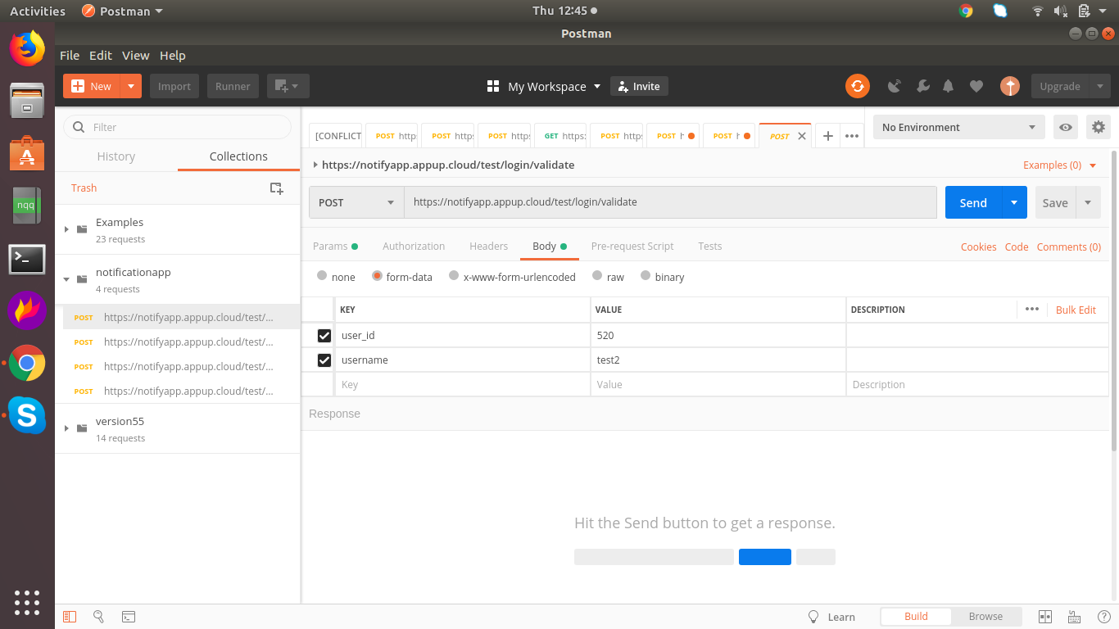

2)Here we have to provide user_id,username to validate the credentials with the session information.

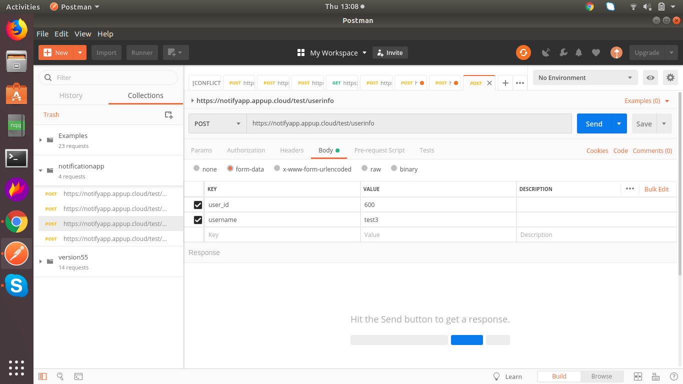

3)Here we have to provide provider name and provider related information.

For example: Provider name: ably

Api_key: {{ablyapikey}}

User_id: {{user_id}}

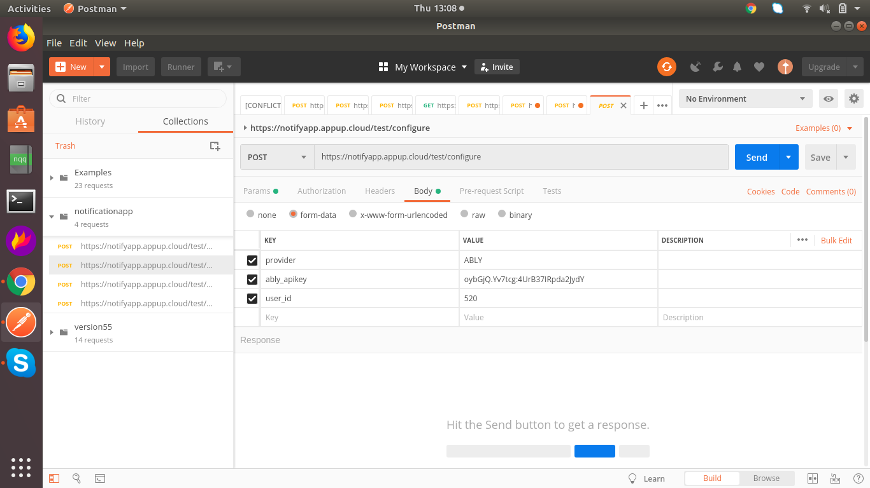

4)Provide the publish message,channel name,userid and apikey that got generated.

